Year 8 MATHEMATICS


Measurement and Geometry: Congruence
NAME: ________________________
Calculators and a one-sided A4 page of notes may be used.

D Grade  Limited achievement | C Grade  Satisfactory achievement | B Grade  High achievement | A Grade  Excellent achievement
Identifies congruency in a pair of triangles in a diagram with the same orientation. | Identifies the congruent pairs of triangles in a similar orientation and communicates the appropriate conditions of congruency with some reference to sides and angles. | Identifies the presence, or not, of a pair of congruent triangles in a set of triangles of varying orientations, and names the appropriate conditions for congruency. | Uses transformations to verify and communicate the conditions of congruency of triangles in a composite diagram.
Calculates the value of a missing side or angle in a pair of congruent triangles. | Completes information in a given diagram and calculates the value of a missing side or angle in a pair of congruent triangles. | Applies the properties of congruent figures to calculate the value of a missing side or angle in a pair of congruent triangles contained in a composite shape. | Applies the correct conventions to set out the reasoning when calculating the value of a side or angle in a pair of congruent triangles contained in a composite shape.
Identifies and correctly names quadrilaterals. | Draws a diagonal of the rectangle, parallelogram or kite to divide the quadrilateral into a pair of congruent triangles and marks the congruent sides and angles. | Uses the geometric properties of the rectangle, parallelogram or kite to establish that a given diagonal divides the quadrilateral into a pair of congruent triangles. | Applies the correct conventions to set out the reasoning when establishing that a given diagonal divides the rectangle, parallelogram or kite into a pair of congruent triangles.
 | Calculates length or angles of a quadrilateral such as a rectangle, parallelogram, rhombus or kite given measurements and using congruency of triangles contained in the figures. | Proves and uses congruency of triangles in given quadrilaterals such as rectangle, parallelogram, rhombus or kite and calculates the value of sides or angles as required. | Solves problems of composite figures containing a rectangle, parallelogram, rhombus or kite using the properties of these figures and the congruent triangles included in them.
 | D |  | C |  |  |  |  |  | B |  |  |  | A
Q | 1 | 2 | 3 | 4 | 5 | 6 | 7 | 8 |  | 9 | 10 | 11 | 12 | 13
Marks | 6 | 3 | 3 | 2 | 4 | 6 | 2 | 2 |  | 2 | 3 | 2 | 5 | 4
My Marks
Total | /9 |  | /17 |  |  |  |  |  | /9 |  |  |  | /9
E |  |  |  |  | D |  |  |  |  | C |  |  |  |  | B |  |  |  |  | A
0 | 5 | 10 | 15 | 20 |  | 25 | 30 | 35 | 40 |  | 45 | 50 | 55 | 60 |  | 65 | 70 | 75 | 80 |  | 85 | 90 | 95 | 100

Question 1. (2 marks: D Grade)
Identify the two pairs of congruent triangles specified below
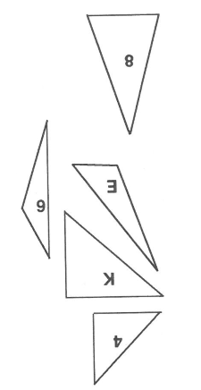

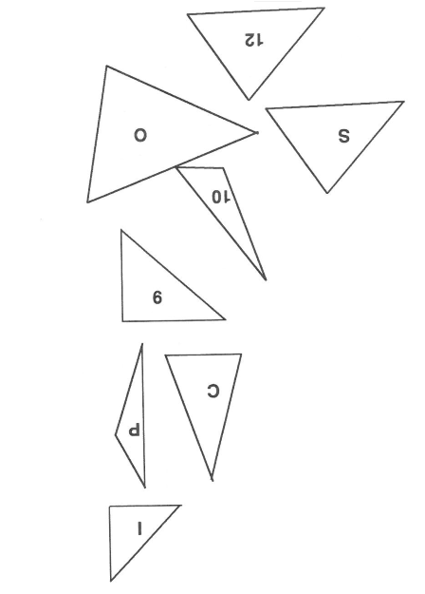

List these two pairs of triangles here. (eg: $∆ Q ≅ ∆ 15$)

$∆$4 $≅$ $∆$9 $≅$

Question 2. These pairs triangles are congruent. Find the value of the variables x and y in each case. (1 Marks: D Grade)

- x =

Question 3. (2 marks: D Grade)
Fully simplify the following ratios

- 4:6 = | - 15:10 =

Question 4. (3 marks: D Grade)
For each of the following, write down the ratio of squares to circles. Give your ratios in their simplest forms.

Question 5. (3 marks: D Grade)
- Find the time difference between 9.15 pm and 10.08 pm

- 4 hours 35 minutes before 10.05 pm

- 7.20 am on Monday and 6.30 pm the next day, Tuesday

Question 6. (6 Marks: C Grade)
- A piece of timber is cut into the ratio 5:3. If the timber is 560 cm, what is the length of the longer piece?

- If it took 7.5 hours to travel the 637.5 km from Busselton to Geraldton, what was the average speed?

- 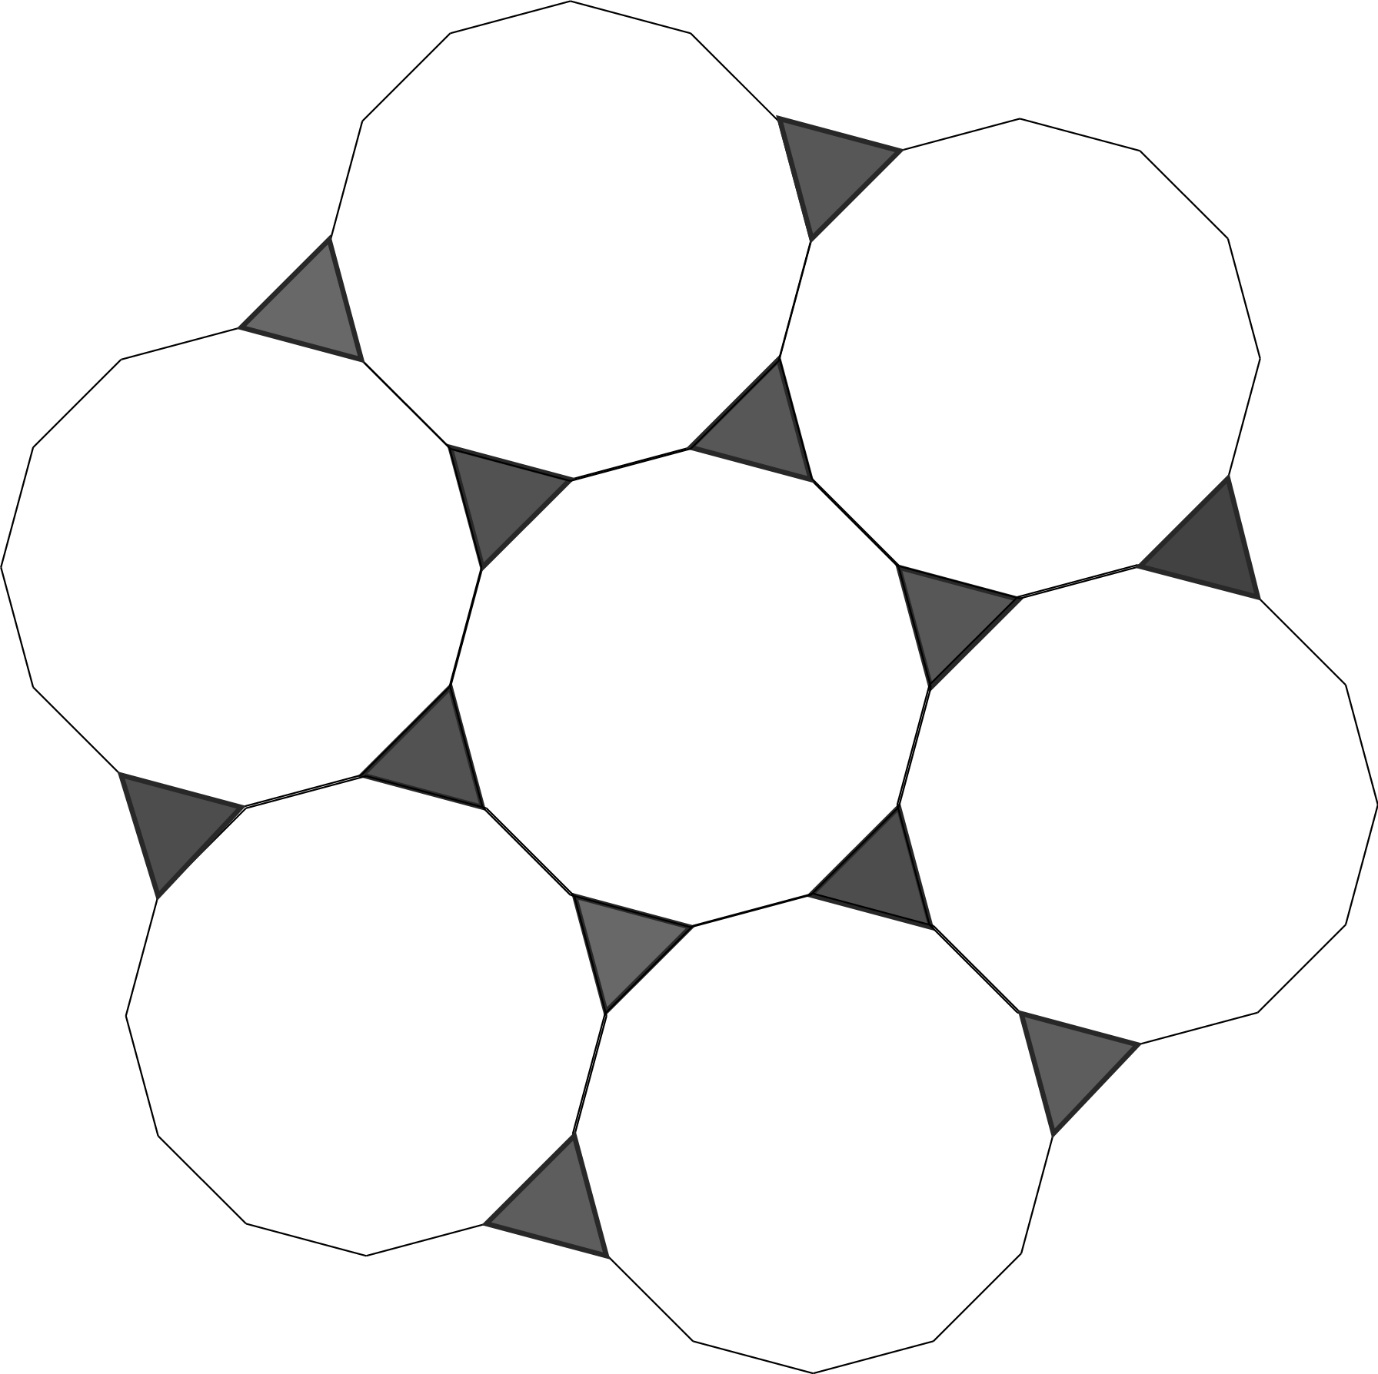A tiling pattern is made up of triangles and dodecagons (12 sided shapes).
If the pattern above was copied several times until there were 49 dodecagons, how many triangles would there be?

Question 7. (2 marks: C Grade)
Are the two triangles shown below congruent. Justify (give reasons) for your answer.
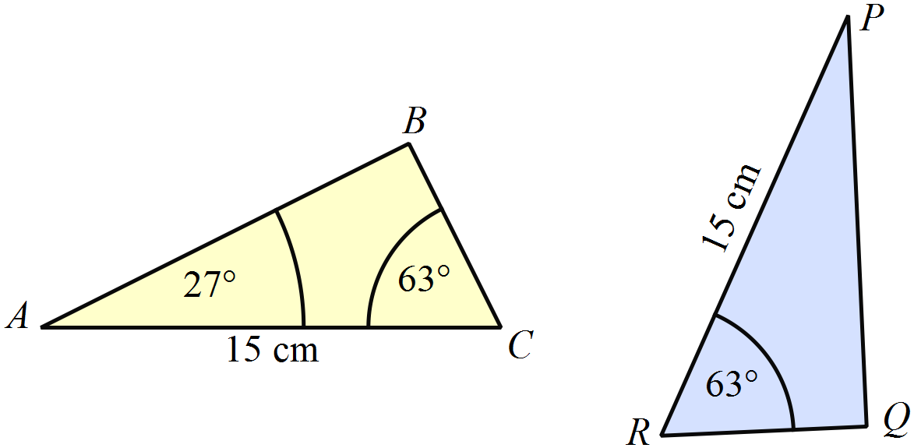 The triangles are NOT drawn to scale.

Question 8. (2 marks: C Grade)
In the parallelogram ABCD, draw in the diagonal $\overline{DB}$ and mark in all congruent sides and angles.

A
C
B
D

Question 9. (3 marks: C Grade)
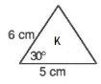
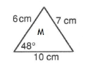
Select the congruent pairs from the following set of triangles. You must justify each selection.
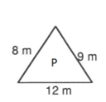
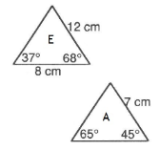

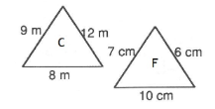
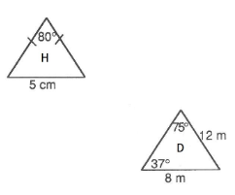
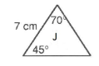

Write your answers using this notation $∆$ Z $≅$ $∆$ X because SAS. Don’t forget to give a reason.

Question 10. (2 Marks: C Grade)
The following pair of triangles are drawn to scale and congruent. Determine the values of the unknowns, indicated by variables.

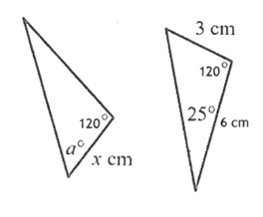
$x$ =

a$°$ =


Question 11. (2 Marks: C Grade)
Tennis training Monday 0630 – 0745 Friday 1650 – 1825

You have a training schedule for tennis. If you follow the schedule, how long will you train each week?

Question 12. (2 marks: C Grade)
Here is part of the morning train from Perth to Midland.
Perth | 07:11 | 07:20 | 07:27 | 07:35 | 07:43 | 07:55
Maylands | - | 07:28 | 07:33 | 07:43 | 07:49 | 08:03
Ashfield | - | - | 07:38 | - | 07:54 | -
Success Hill | 07:25 | - | 07:41 | - | 07:57 | -
Midland | 07:32 | 07:41 | 07:48 | 07:56 | 08:05 | 08:16

- What time is the first train from Maylands that stops at Success Hill?

- Mr. Heathcote is in Perth and wants to be in Midland by 08:00. What is the time of the latest train he can take from Perth?

Question 13. (2 marks: B Grade)
- Lily started reading a book at 1:20 PM She read it for 45 minutes and then went out with her friend Kate. She returned back at 3:00 pm. How long was Lily with Kate?

- John attended a conference at 8:15 AM. The conference lasted for 2 hours and 35 minutes. After the conference, he took a taxi back to his office. The taxi ride took 45 minutes. At what time did he arrived at office?

Question 14. (2 marks: B Grade)
- Which triangle is congruent to  ? (Circle the correct answer)
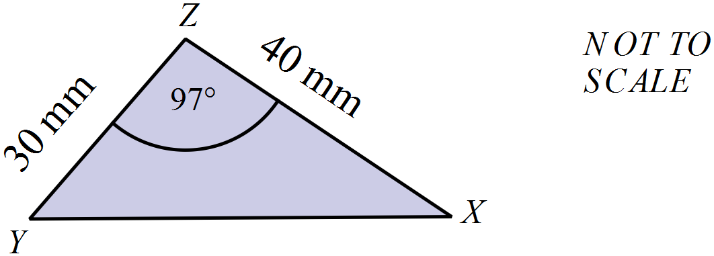

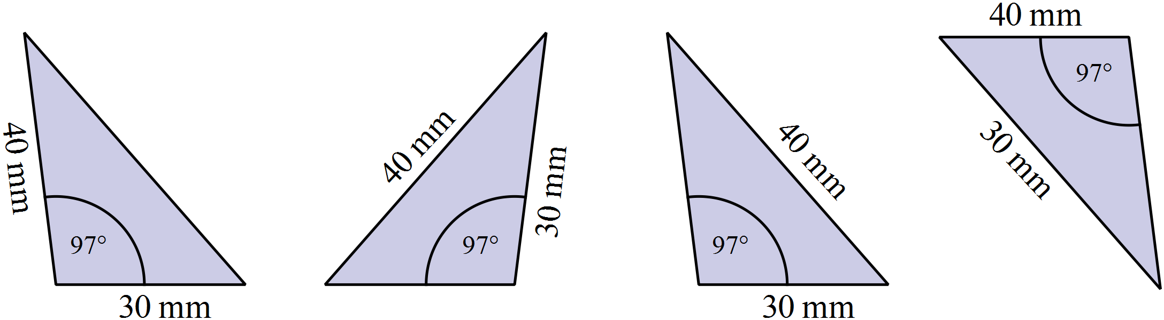 A. B. C. D.

b) Explain why.

Question 15. (3 Marks: B Grade)
Find the missing angles in this shape.
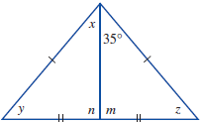
$$x=$$

$$n=$$

$$z=$$

Question 16. (2 marks: B Grade)
PQRS is a kite.
Calculate the size of $∠$RPS
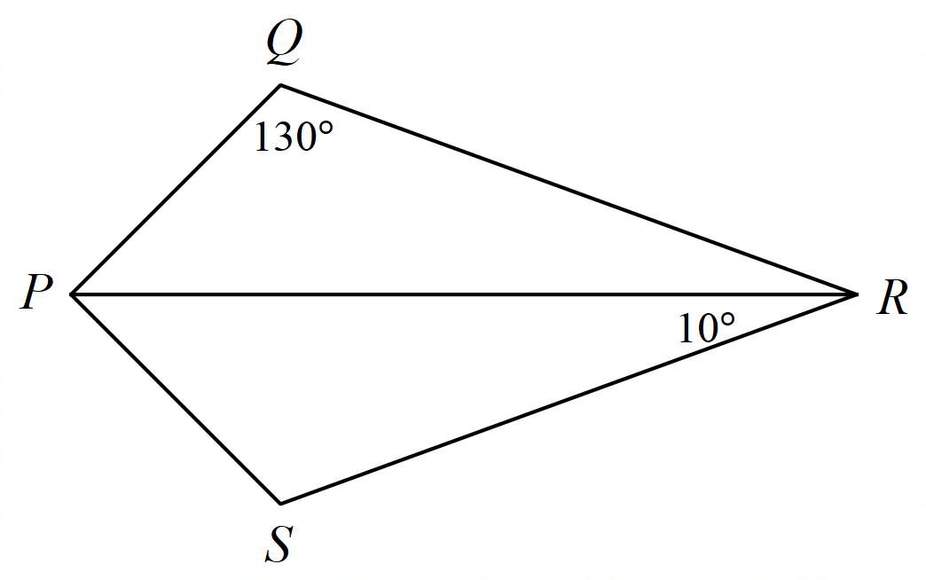

Question 17. (2 marks: B Grade)
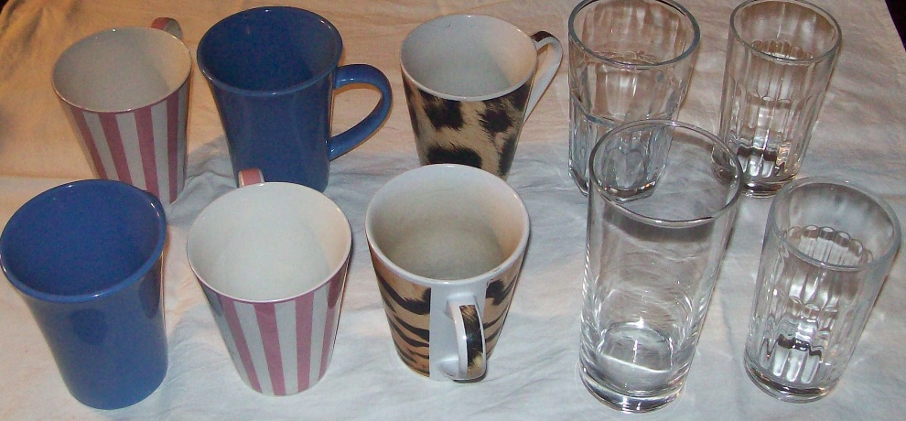
On a table, there are some mugs and some glasses.

a) In the cupboard, the mugs and glasses are in the same ratio as shown above.
If there are 21 mugs in the cupboard, how many glasses are in the cupboard?

Question 18. (3 marks: B Grade)
Deanna drives her car a distance of 450 km at an average speed of 90 km/h.
How much less time would the journey have taken if she had averaged 100 km/h?

Question 19. (5 marks: A Grade)
Which triangles are congruent? Give mathematical reasons for your choice (credit will be given for using the correct notation)
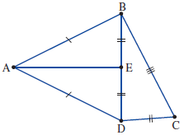

Question 20. (2 marks: A Grade)
To travel 560 km, a car uses 25 litres of petrol.
a) Find the rate at which the petrol is used in litres per 140 km.

Question 21. (3 marks: A Grade)
Susie spends 4 hours on Saturday working in her garden. Of this time, one and a half hours is spent mowing, half an hour spraying bugs and the remaining time weeding.
What is the simplified ratio of the time she spent mowing as to spraying as to weeding?

Question 22. (3 marks: A Grade)
You have been employed to create a TV schedule for a new channel, MeTV. This channel does not have advertisements. You have to plan the TV programmes from 4.00pm to Midnight. Choose which programmes to show based on their running times and then make up your schedule. You cannot show a programme twice!
Drama – Doctor Who (98 mins) , Casualty (87 mins), Merlin (90mins), Doc Martin (30 mins)
Reality TV – Xtra Factor, (25mins), Strictly Come Dancing (90mins), Britain’s Got Talent (98 mins)
Film – Indiana Jones (98 mins), The Incredible Hulk (80mins), Harry Potter and the Goblet of Fire (160 mins)
Sport – Football (25 mins) Skiing (45mins) Rugby (30 mins) Tennis (45mins)

Create a new TV schedule for STV – noting down start and finish times in both the 12 and 24-hour clock. Remember you must ensure we can show the whole programme!
TV Schedule for Saturday
12 hour | 24 hour | Duration | Programme
4.00pm- 5.30pm | 16.00- 17.30 | 90 mins  1 hr 30 min | Merlin
5.30pm – 6.45pm

6.45pm- 7.17pm

 | 19.17- 20.55
 | 20.55- 21.20
9.20pm- 10.40pm

 |  | 80 mins

12 hour | 24 hour | Duration | Programme
4.00pm- 5.30pm | 16.00- 17.30 | 90 mins | Merlin
5.30pm – 6.45pm | 17.30-18.45 | 45 mins | Skiing or Tennis
6.45pm- 7.17pm | 18.45-19.17 | 32 mins | Rugby or Doc Martin
7.17pm – 8.55pm | 19.17- 20.55 | 98 mins | Indiana Jones/ Doctor Who/ BGT
8.55pm-9.20 pm | 20.55- 21.20 | 25 mins | Xtra Factor or Football
9.20pm- 10.47pm | 21.20-22.47 | 87 mins | Casualty
10.47pm -12.00am | 22.47-00.00 | 73 mins | The Incredible Hulk

